**Colorimetric Assay Introduction (Diana)**

The main goal is that you familiarise yourself with the colorimetric assay we are using in the lab. We will test the DEET hydrolase, p055 and p028 for esterase activity on two substrates (4-nitrophenyl butyrate & 4-nitrophenyl trimethylacetate) and amidhydrolase activity on one substrate (4-nitroacetanilide).

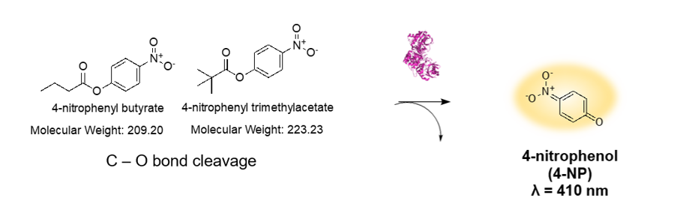

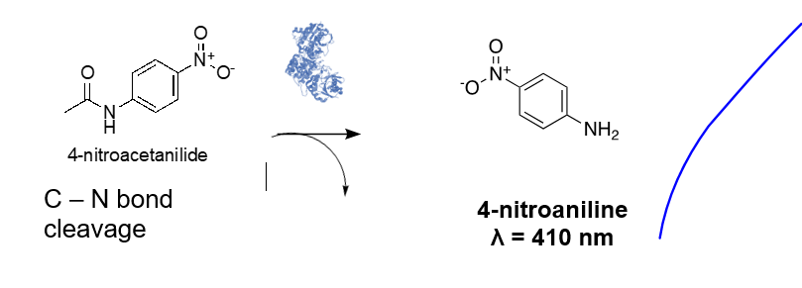

**Buffers & solutions to prepare before starting the experiment**

**TNG buffer:**

100 mM Tris-HCl (pH 7.4),

150 mM NaCl,

10% (vol/vol) glycerol)

**Substrates**

8 mM stock solutions of substrates in 100% EtOH. Store at -20C.

**Enzymes**

DEET hydrolase stored at -80°C in the freezer.

P055 stored at -80°C in the freezer.

P028 stored at -80°C in the freezer.

**How to run the assay**

1. Take the enzymes out of the -80°C freezer and put them on ice.
2. Set up the Plate reader with the settings below:

**Plate reader settings – kinetic mode:**

* Abs 410 nm
* Temp: 37°C
* Read every 1 minute for 1 hour
* Shake continuous do not blank on plate

1. Set up the assay in a 96-well plate accordingly:

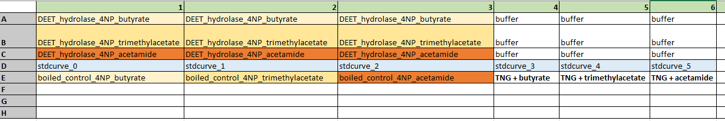

1. Add a standard curve: A 6 point standard curve (e.g., 0-5 uL 8mM 4-NP stock solution, 5-0uL EtOH and 195 uL TNG buffer.
2. Negative controls are:

* Boiled enzyme (100°C for 10 minutes) + TNG buffer + substrates (biotic neg. control)
* TNG buffer only (blank)
* TNG buffer + substrates only (abiotic neg. control)

1. Pipette 185 uL TNG buffer into the wells according to the plate-layout.
2. Add 10 uL purified enzyme.
3. Before starting the measurement add quickly 5 uL substrate in all B wells (in 100% EtOH) to achieve a final conc. of 0.2 mM.
4. Run the platereader!